Brain-Box Game

By

Abdelrahman Hamdy Radwan

Abdelrahman Othman Helal

Section : 9

* Team Members:
  + Abdelrahman Hamdy Radwan
  + Abdelrahman Othman Helal
* Project description:

A game box consists of two games, chess and portals 2D.

Used language :

XNA codede in C# .

Menu:

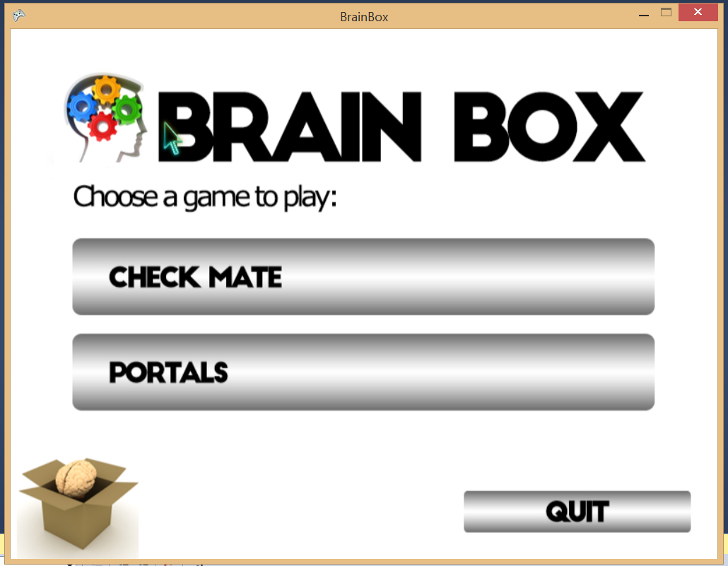

Chess:

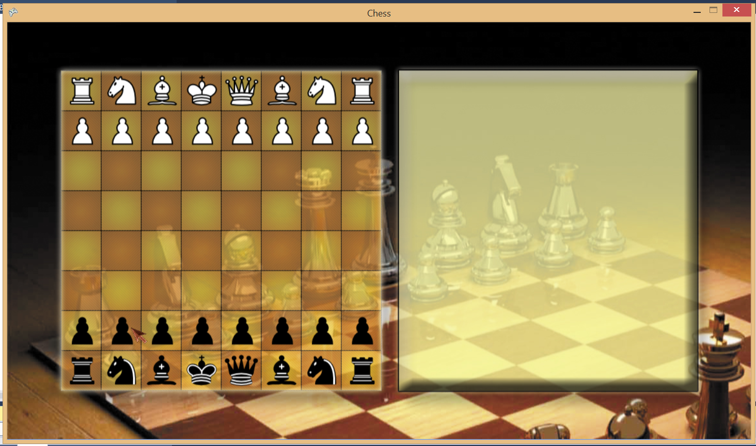

Portals 2D:

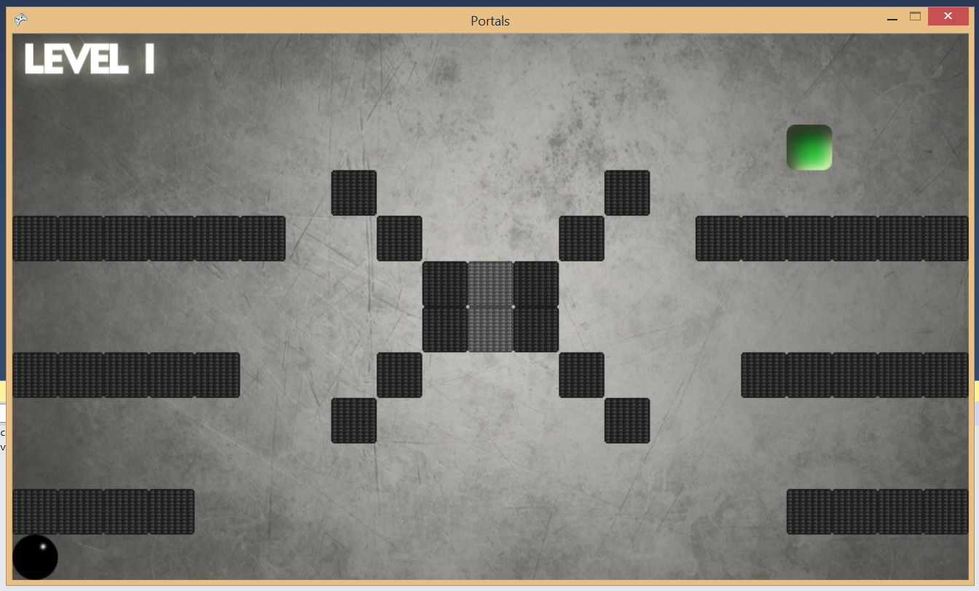

**Concepts Applied:**

**1-OOP:**

**A-Inheritance:**

* **I-Chess:**
  + **Class Rock,Bishop,Pown,…. Are inherited from class Chess Unit.**
  + **Class Rockmove,Bishopmove,pownmove….inherited from the interface class Imovebehavior**
* **II-Portals 2D:**
  + **Classes:**
    - **Abstract: GameLevel , InterActiveObject , Menu, Motion, Portal**
    - **Concrete: Animation , Custom Pointer , Game1 , Hero , InnerMenu, Inportal , LeftMotion , Level1 , Level2 , Level3 , Obstacle, Outportal, Target , Balancing Motion**

**B-Polymerphysm:**

* **I-Chess:**
  + **Virsual function load content in the abstract class , override functions in class Bishop,Rock,…**
* **II-Portals 2D:**
  + **Portal (in , out) .. Loading , initializing the portals**
  + **InterActive Object .. Loading , Moving , initializing the object**

**C-encapsulation && abstraction**:

* I-Chess ,II-Portals:
  + Use classes with private member variables.

**Design Pattern:**

* Strategy Pattern – Motion Class for the hero (Portals)
* Singilton Pattern – Hero class (portals)
* Strategy Pattern – in class imovebehavior